MoodleMoot.cz 2018  a konference eLearning 2018  PragoData Consulting, s.r.o.  Univerzita Hradec Králové  23.-25. 10. 2018,  Hradec Králové | Moodle: The big picture roadmap  Martin Dougimas  Moodle HQ  martin@moodle.com  David Mudrák  Moodle HQ  david@moodle.com

Abstract: Moodle as a project grew up significantly in last two years. Not only the development of the actual Moodle LMS and associated projects - such as the Moodle app or the Moodle Cloud - were boosted. Several new essential projects spinned off to deliver the first promising outcomes in following months.
The presentation will show how the investment from Education For The Many allowed Moodle HQ to expand geographically, increase the number of employees and extend the range of provided services. The latest development also came hand in hand with new challenges, such as seeking for new models of managing the work in teams inside the company as well as co-operation with the existing network of Moodle Partners and user communities.
In the middle of all these dynamic changes, Moodle remains faithful to its original vision to give the world the most effective platform for learning while respecting and encouraging openness, freedom and privacy on all levels.
Keywords: Moodle, roadmap, goals, strategy, values

Informace o autorovi
Martin Dougiamas, dr. h. c.
Email: martin@moodle.com
Zastávaná funkce: CEO
Název instituce: Moodle Pty Ltd

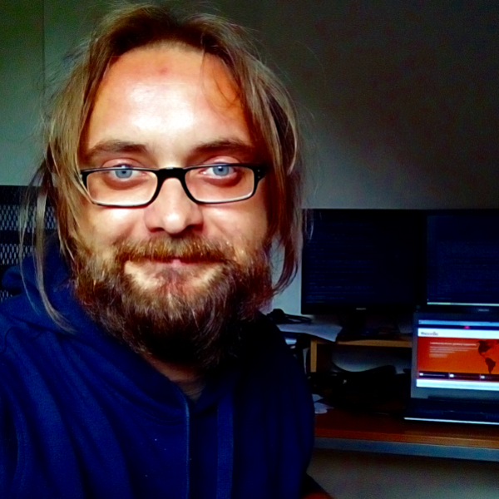
PhDr. David Mudrák, Ph.D.
Email: david@moodle.com
Zastávaná funkce: senior analyst developer
Název instituce: Moodle Pty Ltd

