EduVirtual: Support for Teaching Geography

Tomáš Zeman, Gregor Rozinaj, Marek Vančo, Pavol Podhradský, Jaromír Hrad, Marek Lóderer
Abstract
This paper – as a contribution to the competition – describes EduVirtual experimental system for education that is focused on geography. The system is designed for secondary or elementary schools; it includes a virtual platform and aid for teaching geography using virtual and augmented reality, 360-degree video and other modern e-learning elements. The system is being developed at the STU in Bratislava within the H2020 European project NEWTON (Networked Labs for Training in Sciences and Technologies). The system has already been successfully tested by pupils and teachers at the Bratislava-Lamač elementary school, and autumn pilot runs are being prepared in Dublin and Bucharest.
Keywords
virtual reality, augmented reality, 360-degree video, gamification, modern education
- Introduction
Education with electronic support is currently undergoing significant changes. LMS systems have been routinely used for two decades, and MOOC courses for one decade; similarly old are mobile learning or gamification elements. The last five years of development have brought new opportunities that are related to the development and wide availability of information and communication technologies and procedures that can be effectively used for education; these include mulsemedia, FabLab, 3D, virtual and augmented reality, 360-degree video or multimodal systems.
The paper describes the EduVirtual system, which uses (in addition to older techniques) selected recent technologies for support of geography teaching, namely virtual reality, augmented reality and 360-degree video. The system also includes CMS (Content Management System for administration of courses and users), an educational website, and a blind map with gaming elements and knowledge verification (so-called Globus).
- System Description
Logging in (identification) of participants (students, teachers) is done by reading a QR code; in guest mode, users can log in without the possibility to save a record of their activity and results.
Teachers can use a content management system to define the levels and content of lessons, selection of tests and their contents, the content and specific topics of each lesson, and the language to be used; students’ activity and results can be checked.
Students have three basic options for using the system. The first one is a web portal, i.e. a common electronic interactive textbook. There is no need for special hardware to use it – students can use their laptops, tablets or mobile phones.
The second option is to use virtual reality, augmented reality and 360-degree video. Virtual reality displays a three-dimensional image of the studied scene through 3D glasses. The 360-degree video allows a circular view of a specific place. Augmented reality combines real-world images captured by a cell phone camera with other (expanding) information (text or image). In order to use augmented reality, a mobile phone with an installed application is needed; to use virtual reality, it is necessary to have 3D VR glasses in addition to a mobile phone. A more detailed description is provided in the following chapters.
The third option is to use the Globus test system, which contains the elements of gamification. For a more detailed description, see Chapter 5.
The graphical representation of the system and its components, including examples, is illustrated in a short video presentation [1].
The system is responsive, so it can also be used on mobile devices. Technically, devices running Android are supported.
The system currently supports three languages and makes it possible to specify a detailed curriculum depending on the country of use and type of school (grammar school, secondary vocational school, etc.).
The software and hardware core of the system is formed by the EduVirtual platform, the central server implemented at STU. EduVirtual includes a relational MySQL database, an API interface, and a content management system.
- Virtual Reality and 360-degree Video
The virtual reality and 360-degree video features require special hardware, specifically 3D VR glasses, to which a mobile phone with an installed application running under Android system can be mounted. Common 3D VR glasses are a simple mechanical element, their cost is low, and therefore the use of virtual reality in schools (when it is appropriate to buy glasses for the whole class) does not pose substantial financial burden.
For teaching geography, a number of places (such as cities, monuments) can be virtually crawled in a three-dimensional view using 3D glasses and a mobile application – it is enough to select a specific place on the web portal. An example of a virtual reality view (here in 2D) is provided in Figure 1.
Similarly, within a 360-degree video feature, a number of objects (such as historical monuments) are available for “touring” as if the student stood at the appropriate spot and turned (just like in reality, turning around with 3D VR glasses put on).
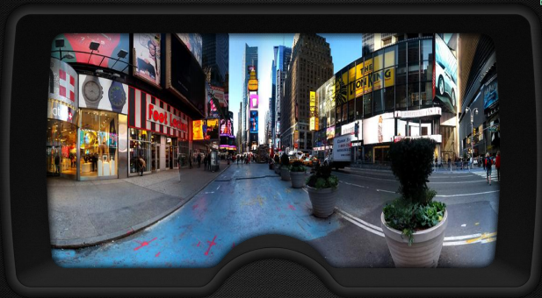
Fig. 1: Virtual reality in 3D glasses
- Augmented Reality
To use the augmented reality feature, a student needs only a mobile phone with an installed application running under Android operating system.
Augmented reality is a combination of real-world images captured by a mobile phone camera and additional information (graphic or text) that is automatically generated by the application, based on the recognized image in the mobile phone. Both the captured image (from the camera) and the additional information are displayed on the phone display.
As for the use of augmented reality in geography teaching, it is possible to acquire additional information about a specific scene captured from the web learning portal, e.g. an important historical building (when it was created, who built it, its social context), or get other views of the scene, etc. An example of augmented reality is shown in Fig. 2.
- The “Globus”
Globus is a common term for a group of functions related to examining and testing of students. Its name comes from a basic view on the web portal used for its activation. Globus contains elements of gamification that aim to make this part of education (generally perceived as unpopular) more attractive.
In addition to common questions (closed, open, etc.), it is possible to prepare questions referring to the map (globe), such as “Where is a particular place?” or “What is at the marked point of the globe?” etc.

Student is prompted by the system to place a specific city or other geographic element (river, mountains) on the blind globe map containing just political borders (the application works not only with a point, but also with a curve or a surface). The student can rotate and zoom the globe using mouse. The flag that marks the point the student has chosen must be placed as close as possible to the real position of the desired location on the globe. The system then calculates the distance between the position determined by the student and the correct location and shows them on the map, including the difference in km. It is possible to define the maximum allowed deviation; accordingly, the correctness of the flag placing can be assessed.

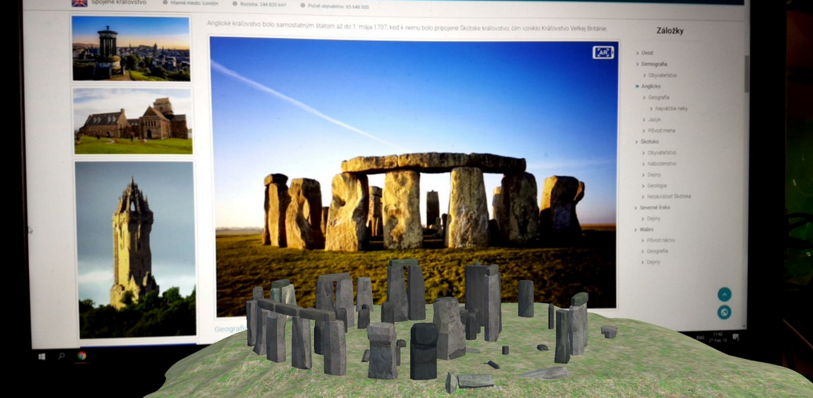
Fig. 2: Augmented reality on a smartphone display
- Pedagogical Aspects
  - Course Information and Organization of Study Activities
EduVirtual educational system is focused on geography. The target group consists of students of all types of secondary schools and pupils of elementary schools. The system allows to adapt the learning content to a curriculum corresponding to the given country, level and type of school; it can be included in the educational process as a supplementary learning aid. The extent of the curriculum and the learning objectives correspond to the specific level and type of school in the given country (SEP – School Education Program). EduVirtual allows integration into LMS systems, so it can use their tools (such as calendar or search tools).
  - Course Design
EduVirtual uses an online solution with client-server architecture. The system is designed for full-time study as a supplementary learning aid. The core learning environment is a website (interactive textbook) featuring modern e-learning procedures (AR, VR and others). With respect to the topic (geography), frequent use of images, audio, video and hypertext is common.
  - Activation of Students
The synchronous and asynchronous communication between teacher and students and among students (including workgroups) is implemented using a superstructure LMS. The system has its own part dedicated to testing. Using EduVirtual, a teacher can review the overall students’ activity as well as detailed activity of a particular student in a clear (and summarized) form. Student activities are recorded in detail.
Various time constraints can be set for tests. Teachers can create their own scenarios (for lessons and tests) and assign them to individual classes or pupils.
- Conclusions
The feedback from the pilot testing at the first school is positive, both from teachers and from pupils. The pilot run included also input and output surveys, input and output tests, and knowledge comparison with a group that underwent only conventional lessons without using the EduVirtual system.
The pupils – as expected – appreciated the visual and technological attractiveness of the system, i.e. the chance to learn in virtual or augmented reality. The Globus test system was also evaluated positively.
In the final phase of the pilot course in Slovakia, STU in cooperation with the Slovak media (TV and radio companies and journalists) organized a media day [3] at the elementary school in Bratislava-Lamač.
Currently, two more pilot runs are being prepared in Romania and Ireland. After their completion, both the experience gathered (especially among teachers) and the results of the surveys, tests and teaching effectiveness evaluation (comparing teaching with and without the EduVirtual system) will be summarized. The complete results and conclusions will be available in the beginning of 2019.
EduVirtual is a versatile system that can be used not only in geography, but also in other subjects. It represents a pioneering effort that seeks to introduce elements of virtual and augmented reality to routine education at secondary or elementary schools. The main objective of the experimental period is to determine the contribution to learning efficiency and to verify whether the technical possibilities of schools are at a level allowing routine and efficient use of such systems.

References
- NEWTON Education App - EduVirtual AR. YouTube [online]. 30. 7. 2018 [cit. 2018-08-25]. Available: https://youtu.be/yftfwDX0LWM
- EU HORIZON 2020 Project NEWTON: Networked Labs for Training in Sciences and Technologies [online]. Dublin, Ireland, 2015 [cit. 2018-08-26]. Available: http://www.newtonproject.eu/
- Vyučovanie budúcnosti rieši európsky projekt Newton. Slovenská technická univerzita v Bratislave [online]. Bratislava, 27.6.2018 [cit. 2018-08-30]. Available: https://www.stuba.sk/buxus/generate_page.php?page_id=12209

Ing. Tomáš Zeman, Ph.D.

Czech Technical University in Prague, Faculty of Electrical Engineering

Technická 2, Praha 6, CZ-166 27, Czech Republic
e-mail: zeman@fel.cvut.cz

Prof. Ing. Gregor Rozinaj, PhD.

Slovak University of Technology in Bratislava, Faculty of Electrical Engineering and Information Technology, Ilkovičova 3, Bratislava, SK-812 19, Slovak Republic
e-mail: gregor.rozinaj@stuba.sk

Ing. Marek Vančo, PhD.

Slovak University of Technology in Bratislava, Faculty of Electrical Engineering and Information Technology, Ilkovičova 3, Bratislava, SK-812 19, Slovak Republic
e-mail: vanco@ut.fei.stuba.sk

Prof. Ing. Pavol Podhradský, PhD.

Slovak University of Technology in Bratislava, Faculty of Electrical Engineering and Information Technology, Ilkovičova 3, Bratislava, SK-812 19, Slovak Republic
e-mail: pavol.podhradsky@stuba.sk

Ing. Jaromír Hrad, Ph.D.

Czech Technical University in Prague, Faculty of Electrical Engineering

Technická 2, Praha 6, CZ-166 27, Czech Republic
e-mail: hrad@fel.cvut.cz
Ing. Marek Lóderer
Slovak University of Technology in Bratislava, Faculty of Informatics and Information Technologies, Ilkovičova 2, Bratislava 4, SK-842 16, Slovak Republic
e-mail: marek_loderer@stuba.sk

